`
Vulcan Activity Tracker
Weekly Report

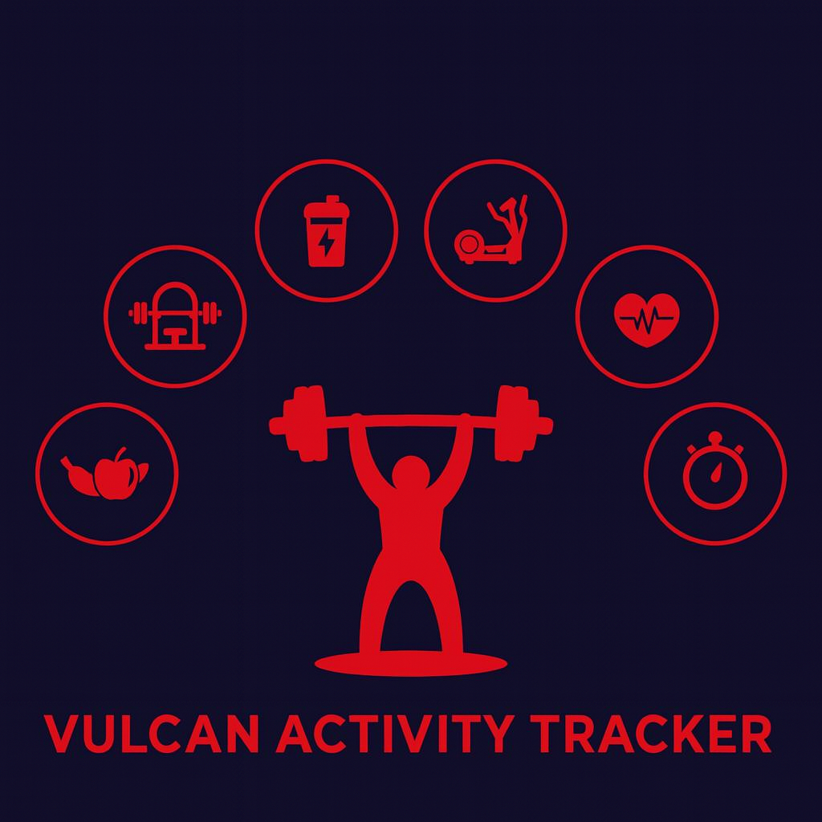

Week 12
Team Members:
Margo Bonal
John Gerega
Luke Ruffing

Professor: Dr. Weifeng Chen

Course: CMSC-4920-Senior Project II
School: Pennsylvania Western University

Table of Contents

Project: Vulcan Activity Tracker 2
Goals Accomplished: 2
Team Progress: 3
Gantt Chart: 3
Week 12 Plan: 4
Member Contribution: 5

Project: Vulcan Activity Tracker
To complete the proposed goals in previous week’s report, our team followed a strict schedule of daily progress and communication. Our team had 4 main goals to complete, which were to finalize some of the components of the tracker, debug previously added features, work on getting the tracker ready for web deployment, and to work on the teams page. Since each goal needed time allocation for development and testing, we assigned each goal priority based on how they were connected to each other. Throughout the discussion, we decided that getting the tracker ready for deployment was the most important task. Achieving this goal will help us progress into having a finished product.

Goals Accomplished:
One of the goals accomplished this week was further development of the clubs page. Although the clubs page has had some basic features working for some time now, with the deadline of deployment coming up it definitely needed some work. The first change was some very needed UI changes, we made the page much more pleasing to the eyes and added a button in the top right corner that will navigate the user to a create a club page. The second feature we added to was the club details page. When you click the “view” button on a club you will be navigated to its details page, where you will now find the addition of a club leaderboard, member list, and a recent activity list.
Challenges Faced:
- While working on the clubs page we encountered a problem when we displayed the club members recent activities. The problem was that displaying the activities and adding the like feature to said activities, a member could like their own activity. This is not something we intended users to be able to do.
Solutions:
- To solve this problem we first added a backend check to not allow users to like their own activities, and if they tried they would receive an error message. After fixing the backend check we add a front end fix by disabling the like button on the users own activities. The “Thumbs Up” like button and like count is still on a users own activities to display their like count, but the button is not clickable for the user.

Team Progress:
Our team made substantial progress over the past week. The encroaching deadline is motivating us to move forward with an increased development pace. Many features have been tweaked in our tracker this week, to start off we added many needed components to the clubs and teams pages. We also added an inbox feature that as of right now is only used for invites to a team or a club, but in the future could be used for much more. While much had been added to the tracker the most substantial progress to our tracker this week has definitely been the research and work that is being done to get our tracker launched.

Gantt Chart:
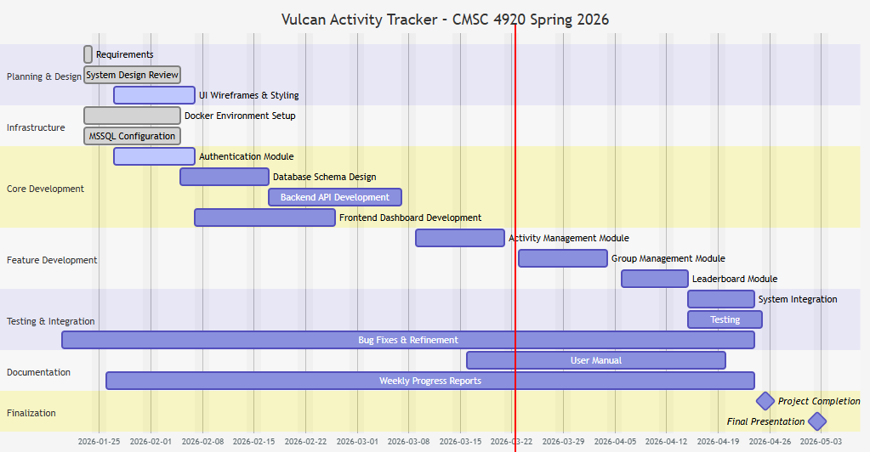

Week 13 Plan:
Our current plan for week 13 is going to focus on wrapping up feature development and work on getting ready for deployment. First off we want to work on finishing up our trackers features by adding any needed components. We also want to continuously test our tracker in search of any bugs or broken features. This upcoming week we really want to focus on starting work on our final presentation slides and documents such as the user manual.

Member Contribution:

Team Members
Margo Bonal: | - Team meetings, Week 12 Report & Slides, Website development, hosting research
John Gerega: | - Team meetings, Week 12 report and slides
Luke Ruffing: | - Team meeting, Week 12 Report & Slides, Clubs page

